Advantages of Docker
1-No pre-allocation of memory

2-CI-Efficiency:Docker enables you to build contanier
image and use that same image across every step of deployement
process.

3-Less Cost
4-It is leight weight
5-it can run Physical Hardware/Virtual hardware or on Cloud
6-we can re-use the image
7-It took very less time to create contanier

Important Note:
There are two things 'Image' & 'Contanier'

When contanier running image is know as contanier
when contanier stop contanier know as image

when Image run its become container and when we send it
it send in image form

Note 2:when we send the data we cannot send contanier we
always share container Image.

When we request any image from docker hub docker engine
store one copy in docker engine memory and then share with containers
any next time or other contanier need this image we request to docker engine not docker hub

Jab kisi container ko same software ure os chiya hota hay
may us ki image bana lita ho ure dushra contanier say share kar
dita ho ure jab ko us image say container baniy ga tu sari require
things is ka pass a jay gi

if we want to change anything in image(unchangeable) we cannot change in
image for changing we use contanier (changeable)

Disadvantages of Docker:
->It Cannot support Cross platform compatibility means if an
application is designed to run in a docker
->Docker is not good solution if application that require Rick
GUI
->Difficult to manage larg amount of containers
->Container on windows,thun it Cannot run on linux or vice versa

Docker is suitable when the development os and testing os are same
if the OS is different we should use VM-Ware

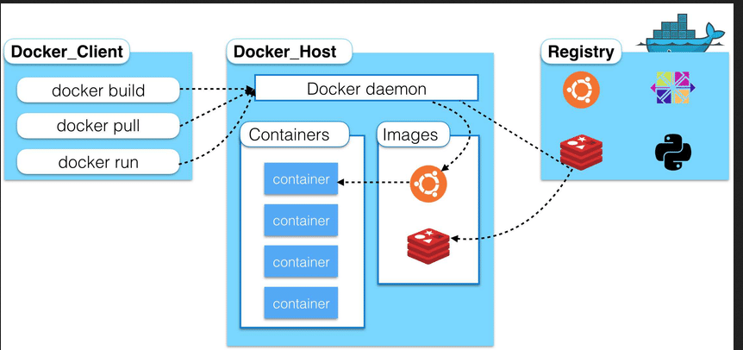

Container use the layer file System It work Layer by Layer

Docker is a Ecosystem means container banana ka lia bahut sara chizo ki zarorat hoti hay jis ko may ecosystem kahta ho ecosystem means set of software or packages

Docker ecosystem:
Components of Docker Ecosystem:
1-Docker client :
Working area (jis may hum apna sara kam karta hay like docker file banana etc)

Defination:
- Docker user can interact with docker daemon through a client
- Docker client use commands and REST API to communicate with the docker daemon
- when a client run any command on the docker client terminal ,the client terminal send these commands to the docker daemon
- It is possible for docker client to communicate with more then one daemon

2-Docker Daemon or Docker Server /Docker engine
Ya image ko contanier may convert karta hay ure commands ko execute karta ha
Defination:
- Docker daemon runs on Host operating system
- it is responsible for running Containers to manages docker services
- Docker daemon can communicate with other Daemon

3-Docker Hub/Registory
- Docker registry manages and store the docker images
- There are two types of registries in the docker

- public Registry:public registry is also called docker hub
- private registry:It is used to share images with the enterprise
4-Docker Images:
- It is like template. With the help of this we create a container.
- Docker images are the read only binary template used to create docker container
OR
- Single file with all dependencies and and configuration required to run over program /software
5-Docker compose :
With the help of this we can run many container at the same time.

Docker host:(this is not a part of docker ecosystem) /my computer or leptop
Docker host is used to provide and environment to execute and run applications it Contains the docker daemon,images containers network and storage

Ways to create images :

way 1:Take image from docker hub(for accessing)
way 2:Create image from docker file
way 3:create image from existing docker container

Container :

- Container hold the entire packages that is needed to run the application
OR
- In other words we can say that image is a template and the container is a copy of that template
- Container is like a virtual machine
- Image becomes container when they run on docker image

